Top Beatles

- A Day In The Life
- Girl
- Here Comes The Sun
- The Long And Winding Road
- Across The Universe
- Magical Mystery Tour
- In My Life
- A Hard Day's Night
- Hey Bulldog
- Polythene Pam
- The Fool On The Hill
- Sergeant Pepper's
- Hello Goodbye
- Eight Days A Week
- Penny Lane
- Strawberry Fields Forever
- Mean Mr. Mustard
- The Night Before
- Fixing A Hole
- With A Little Help From My Friends
- You Won't See Me
- Back In The USSR
- It's Getting Better
- Lovely Rita
- Her Majesty
- PS I Love You
- Do You Want To Know A Secret
- Anytime At All
- Please Please Me
- She's Leaving Home
- Only A Norhtern Song
- Can't Buy Me Love

Records after split up:
1971 – We Measure Our Pain

- Working Class Hero
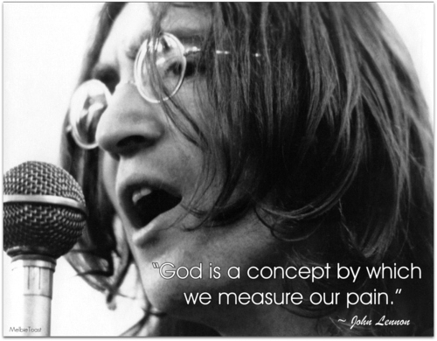
- God
- Cold Turkey
- Give Peace A Chance

- The Lovely Linda
- Maybe Im Amazed
- That Would Be Something
- Every Night
- Junk
- Teddy Boy

1972 – Looking For A Home

- Woman Of The Night
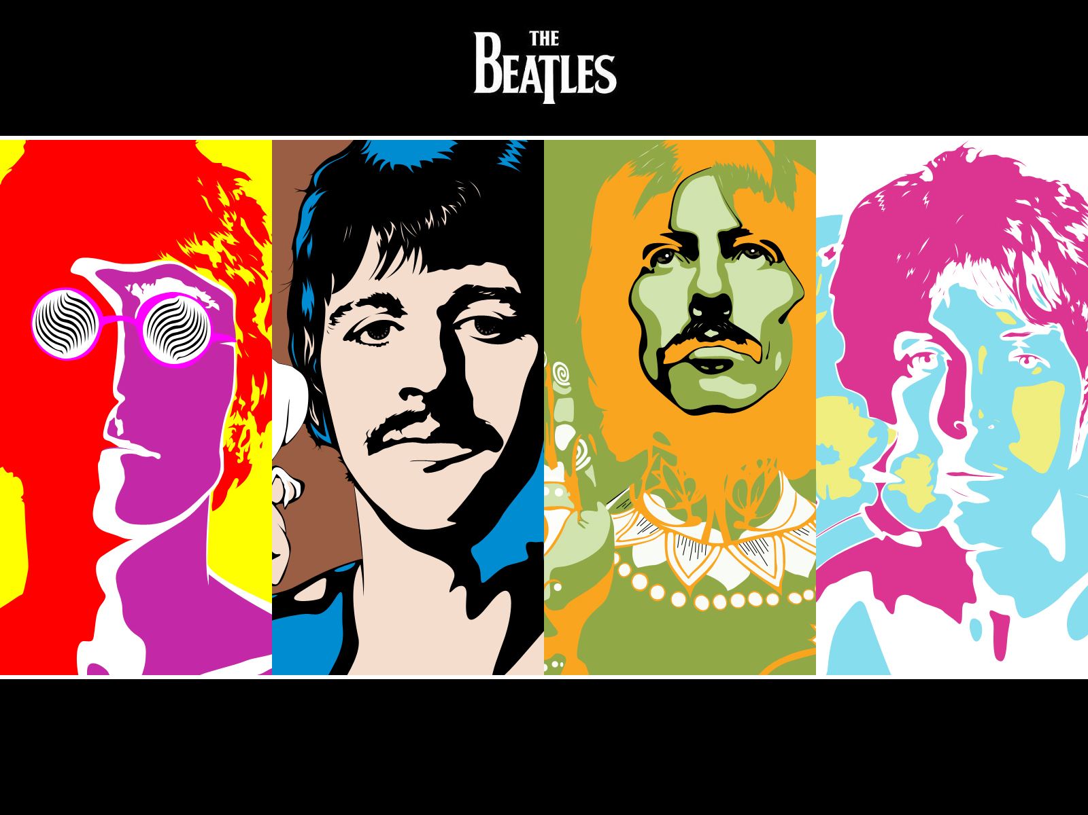
- Beacoups Of Blues
- Fastest Growing Heartache

- Too Many People
- Uncle Albert/Admiral Halsey
- Heart Of The Country
- Monkberry Moon Delight
- Eat At Home
- Long Haired Lady
- The Back Seat Of My Car
- Another Day

1973 – It Takes So Long

- Imagine
- Jealous Guy
- Gimme Some Truth
- How Do You Sleep
- Oh Yoko

- Photograph
- It Dont Come Easy
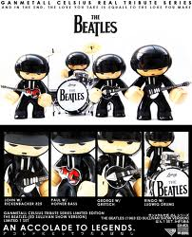
- My Sweet Lord
- Wah-Wah
- Isnt It A Pity
- What Is Life
- All Things Must Pass

1974 – Is It True

- Mumbo
- Be Bop

- Wild Life
- Dear Friend

- Woman Is The Nigger Of The World
- Sisters Oh Sisters
- The Luck Of The Irish
- Mind Games
- Bring On The Lucie

- Band On The Run
- Jet
- Bluebird
- Mrs.Vandebilt

1975 – (We All) Shine On

- My Love
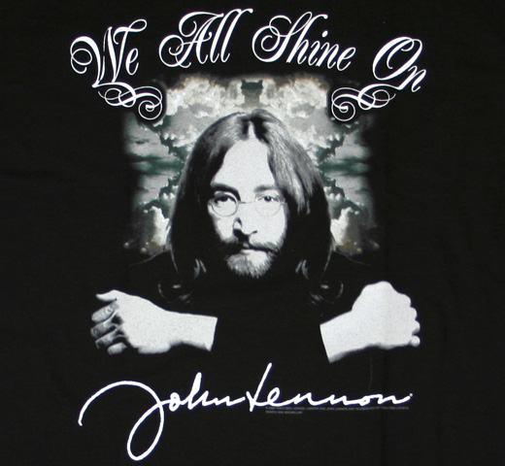
- C Moon
- Hi Hi Hi

- So Sad
- Ding Dong Ding Dong
- Dark Horse

- Give Peace A Chance
- Cold Turkey
- Instant Karma
- Power To The People
- Mother
- Happy Christmas (War Is Over)

1976 – So Many People

- Venus And Mars
- Rock Show

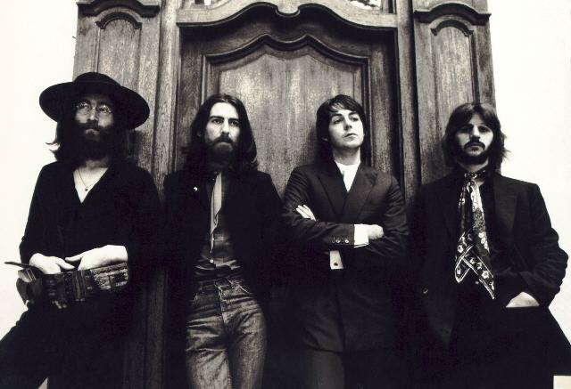
- Snookeroo
- Goodnight Vienna
- All By Myself
- Cooking In The Kitchen Of Love
- A Dose Of Rockn Roll
- Hey Baby

- Bangla Desh
- Is It He
- Give Me Love
- Living In The Material World
- The Way The World

1977 – All I Got To Be Is Be Happy

- Live And Let Die
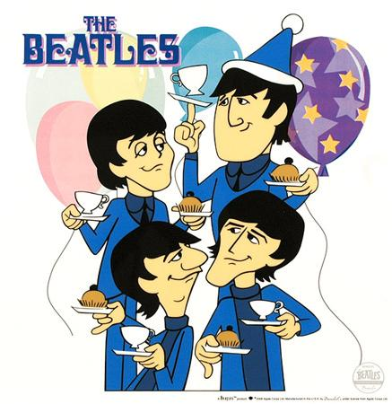
- Let Them In
- Silly Love Songs
- Sally G

- Blow Away
- Faster
- Got My Mind Set On You
- You
- Beautiful Girl
- Crackerbox Palace

- Drowning In The Sea Of Love
- Can She Do It Like She Dances

1978 – Silver Rain

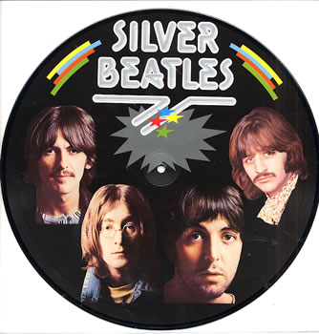
- Scouses Dream
- A Man Like Me
- Tonight

- London Town
- Children Children
- With A Little Luck
- Deliver Your Children
- Morse Moose And The Grey Goose
- Girls School
- Getting Closer
- Spin It On

1979 - The Yellow Album 1970 – 1978 (3 LPs)

- Working Class Hero
- God
- Cold Turkey
- Give Peace A Chance
- Maybe Im Amazed
- Uncle Albert/Admiral Halsey
- Eat At Home
- Another Day
- Imagine
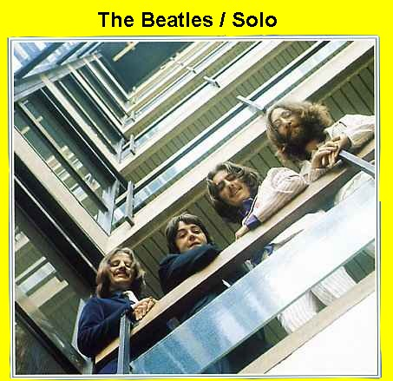
- Jealous Guy
- Gimme Some Truth
- Oh Yoko
- It Dont Come Easy
- My Sweet Lord
- Wah-Wah
- Isnt It A Pity
- What Is Life
- Mind Games
- Band On The Run
- Jet
- My Love
- Hi Hi Hi
- Instant Karma
- Power To The People
- Mother
- Venus And Mars
- Rock Show
- Bangla Desh
- Give Me Love
- Live And Let Die
- Let Them In
- Silly Love Songs
- New York City
- Happy Christmas (War Is Over)

1980 – I Need Love

- Coming Up
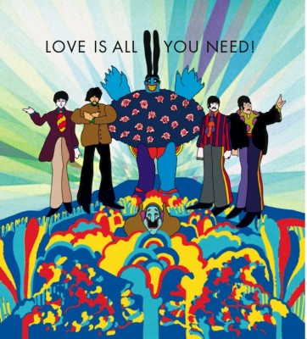
- Goodnight Tonight
- Daytime Nightime Suffering
- Waterfalls
- One Of These Days

- Just Like Starting Over
- Kiss Kiss Kiss
- Woman
- Dear Yoko
- Back Off Boogaloo
- Stop And Take The Time To Smell The Roses
- Private Property
- Attention

1982 – Its Breaking Us Down
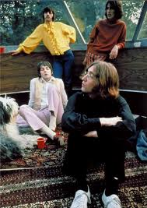
  - Thats The Way It Goes
  - I Really Love You
  - Gone Troppo
  - Baby Dont Run Away
  - Dream Away
  - Weight Of The World
  - Dont Know A Thing About Love
  - Dont Go Where The Road Dont Go
  - Golden Blunders
  - What Goes Around

  - Tug Of War
  - Take It Away

1984 – Perfect Harmony

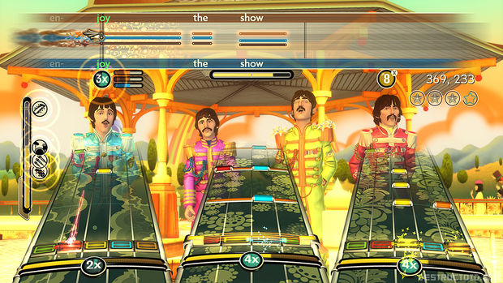
- Brandy
- Hopeless
- Picture Show Life

- Pipes Of Peace
- Say Say Say
- So Bad
- The Man
- Average Person
- We All Stand Together
- Simple As That
- Ebony And Ivory

1986 – Thats Not My Style
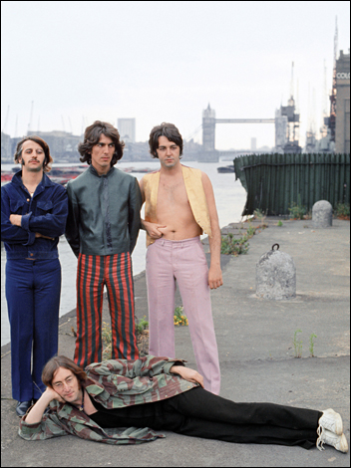
- No More Lonely Nights
- Wanderlust
- Ballroom Dancing
- For No One
- Only Love Remains
- Press To Play
- Move Over Busker
- Angry
- Spies Like Us

- Once Upon A Long Ago
- New York City

1988 – Long Time Ago

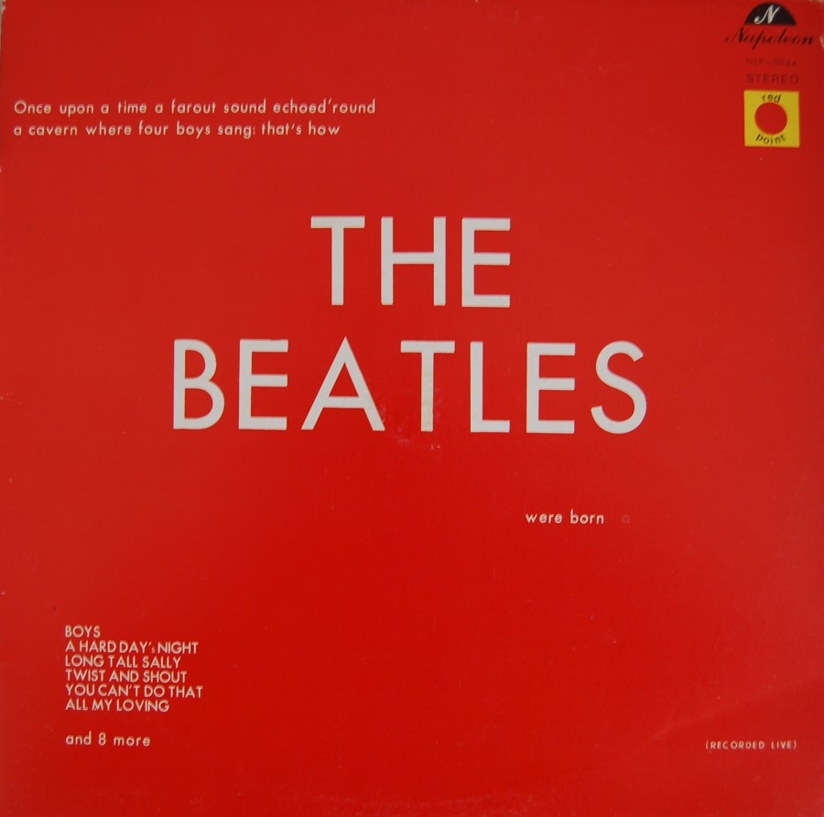
- Thats What It Takes
- Fish On The Sand
- This Is Love
- When We Was Fab
- Shangai Surprise

- Thank You Girl
- Ill Get You
- Yes It Is
- Rain
- You Know My Name

1992 – There Never Could Be A Better Moment

- My Brave Face
- We Got Married
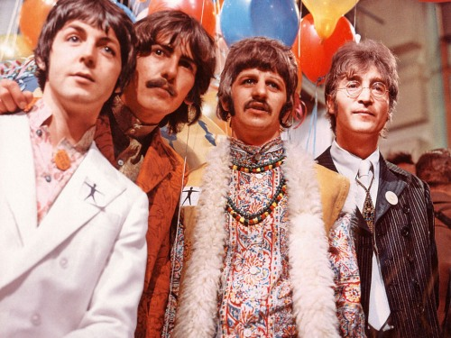
- Put It There
- Figure Of Eight
- This One
- Flying To My Home

- Long Lost John
- Im The Greatest

- Off The Ground
- Looking For Chances
- Hope Of Deliverance
- Winedark Open Sea
- Cmon People

1994 - The Green Album 1979 – 1994 (2 Cds)

- Just Like Starting Over
- Woman
- Blow Away
- Got My Mind Set On You
- With A Little Luck
- Coming Up
- Goodnight Tonight
- Weight Of The World
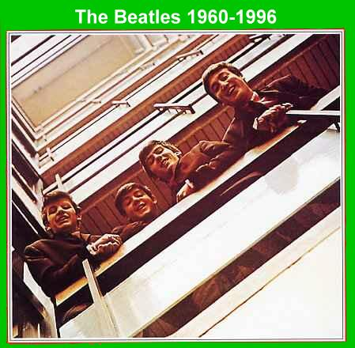
- Tug Of War
- Ebony And Ivory
- Pipes Of Peace
- Say Say Say
- No More Lonely Nights
- Press To Play
- Spies Like Us
- Once Upon A Long Ago
- When We Was Fab
- Thank You Girl
- Ill Get You
- Yes It Is
- Rain
- You Know My Name
- Long Lost John
- Im The Greatest
- My Brave Face
- Figure Of Eight
- This One
- Cooking In The Kitchen Of Love
- Hey Baby
- Off The Ground
- Hope Of Deliverance
- Cmon People

1995 – I Love You (2Cds)

- I Lost My Little Girl
- Free As A Bird
- In Spite Of All The Danger
- My Bonnie
- Aint She Sweet

- Cry For A Shadow
- Three Cool Cats
- How Do You Do It
- You Know What To Do
- Leave My Kitten Alone
- Christmas Time Is Here Again
- Real Love
- If You Got Trouble
- That Means A Lot
- 12 Bar Original
- Shes A Woman
- A Beginning
- Not Guilty
- Whats The New Mary Jane
- Step Inside Love
- Las Paranoias
- Teddy Boy
- Mailman Bring Me No More Blues
- Come And Get It

1999 – When You Are Ready

- The Song We Were Singing
- The World Tonight
- If You Wanna

- Somedays
- Young Boy
- Calico Sky
- Flaming Pie
- Little Willow
- Beautiful Night
- One
- Drift Away
- I Was Walking

- Run Devil Run
- What It Is

2003 – Here We Are

- Lonely Road
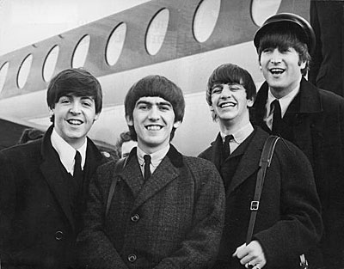
- She Given Up Talking
- Driving Rain
- I Do
- Back In The Sunshine Again
- Rinse The Raindrops
- Freedom
‘
- Any Road
- Pisces Fish
- Stuck Inside A Cloud
- Run So Far
- Brainwashed

2005 –Cmon Brother

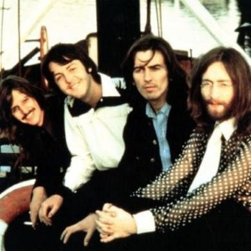
- Eye To Eye
- Missouri Loves Company
- Memphis In Your Mind
- Love First Ask Questions Later
- Elizabeth Reigns

- Fine Line
- Jenny Wren
- Friends To Go
- Promise To You Girl
- Anyway

2009 – To A Much Better Place
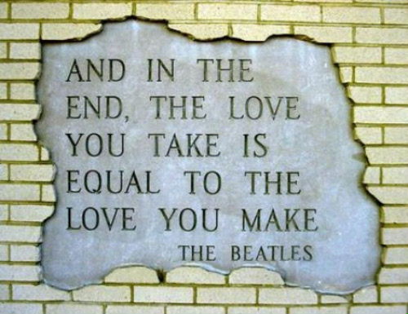
- Dance Tonight
- Only Mama Knows
- Mister Bellamy
- Vintage Clothes
- Feet In The Clouds
- End Of The End
- Liverpool 8
- Think About You
- Gone Are The Days
- If Its Love What You Want

2010 - The Pink Album 1995 – 2008

- I Lost My Little Girl
- Free As A Bird
- In Spite Of All The Danger
- Cry For A Shadow
- Aint She Sweet
- You Know What To Do
- Christmas Time Is Here Again
- Real Love
- If You Got Trouble
- That Means A Lot
- Not Guilty
- Whats The New Mary Jane
- Step Inside Love
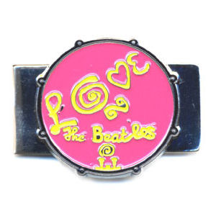
- Las Paranoias
- Come And Get It
- The Song We Were Singing
- If You Wanna
- Somedays
- Young Boy
- Beautiful Night
- One
- Run Devil Run
- What It Is
- Lonely Road
- Back In The Sunshine Again
- Rinse The Raindrops
- Freedom
- Any Road
- Stuck Inside A Cloud
- Brainwashed
- Memphis In Your Mind
- Elizabeth Reigns
- Fine Line
- Friends To Go
- Dance Tonight
- Mister Bellamy
- Liverpool 8
- Gone Are The Days
- A Wonderful Christmas Time
- End Of The End

